Assignment: Strategic Partnerships Growth Plan

Overview
PayMe provides a suite of three core products for small businesses:
- Payments: A platform for online and in-person payment processing.
- Accounting: Tools for invoicing and full bookkeeping.
- Marketing (Promoter): Solutions for digital marketing and lead generation.
Our business model is distribution through partners who already provide business-facing solutions (such as CRMs, website builders, invoicing tools, scheduling software, and marketplaces). These partners integrate our services into their platforms, enhancing their value proposition while generating additional revenue through a revenue-sharing model with PayMe.

Objective
Plan and execute how you would reach 100K ILS in Monthly Recurring Revenue (MRR) by Month 4 through new distribution partnerships for PayMe.

Instructions
- Your task is to map the relevant partners needed to reach the goal and detail your execution plan using the 3 tables provided.
- In order to select the right partners, perform market research to find the most suitable partners and estimate the number of their sellers. Also, assume which percentage of the sellers will onboard and on what timeline (not all sellers will join on day one).
- Clearly specify in the tables:
  - Who are the partners you selected and why
  - Which actions will be performed each week.
  - Which partners you plan to sign and launch.
- Use the ARPU, activation rate, and sales cycle data provided.
- Make assumptions where data is missing (e.g., partner size, outreach success rates) and state them clearly.
- Deliverable: Complete all tables below to illustrate your detailed plan.

Business Context

Attribute | Payments | Accounting | Marketing
ARPU | 100 ILS | 150 ILS | 1,500 ILS
Activation Rate | 15% | 25% | 25%
Average Sales Cycle | 4 weeks | 2 weeks | 4 weeks
Geography | Israel, US, Europe | Israel only | Israel only
Example Partner Types | SMB platforms (CRMs, website builders, scheduling software), marketplaces | SMB solutions | Any organization capable of distributing marketing services

Partner Selection

Partner Name | Relevance for distribution of which products? | Number of sellers? | Why selected?

Table 1: Weekly Activity & Partner Progress (Weeks 1–12)
(create google sheet - this is an example)

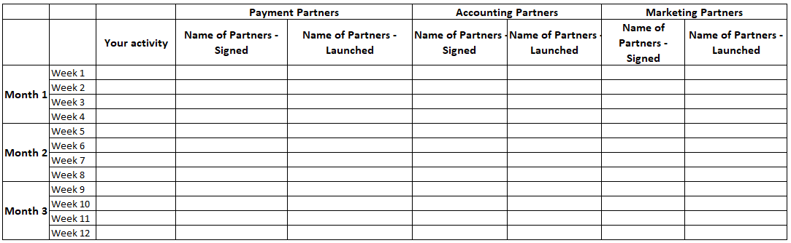

Table 2: Monthly Revenue Forecast
(create google sheet - this is an example)

